**Group Cycle Advanced**

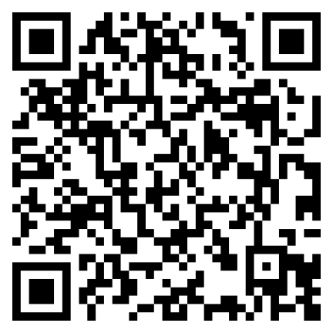

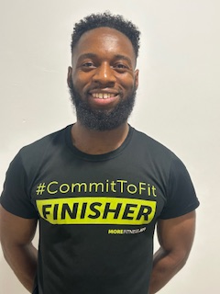

**About me**

**Hi, I’m Renaldo, a certified Personal Trainer and Sports Scientist with a deep passion for fitness and well-being. What sets me apart is my ability to inspire and motivate clients with my charismatic approach, helping them push beyond their limits and achieve their goals.**

**My approach:**

I believe every client is unique, so I tailor training programs to suit your individual needs, preferences, and schedule. By integrating personalized nutrition advice and placing a strong emphasis on overall well-being, my approach focuses not only on transforming your body but also on strengthening your mind and confidence.

**My Qualifications**

**Sport Science with Management**

Degree

**Personal Trainer** Level 3

**Gym Instructor**

Level 2

**Adapting Fitness Instruction for Adolescent’s**

Level 2

**My specialties**

* Weight Loss and Fat Loss
* Strength & Conditioning
* Muscle Building
* Training Adolescents
* Core stability and so much MORE!



I’m regulated by:

The Chartered Institute for the Management of Sport and Physical Activity (CIMSPA) Member number 35366

PERSONAL TRAINER PROFILE

Renaldo

Aggrey

**How do you book me?**

Email: Renaldoaggrey@gmail

Or complete the questionnaire using the barcode below.