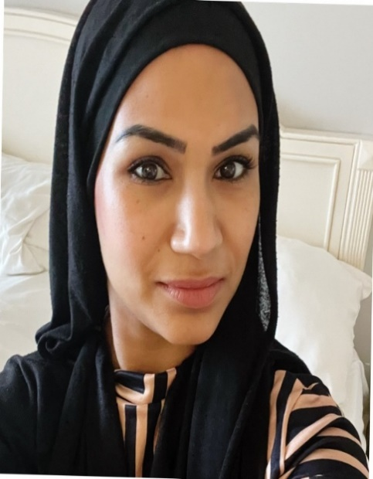

PERSONAL TRAINER PROFILE

Romana Khan

**How do you book me?**

Email: romana_naz786@hotmail.com

or ask at reception for more details.

**About me**

**Hi, I’m Romana and I’m a certified Personal Trainer. My journey into fitness began after having my four amazing children, and I know firsthand how vital it is to prioritize our health – not just physically, but mentally too.**

**I have a deep passion for helping others achieve their health and fitness goals.**

**I can help with:**

* Core strength
* Losing weight
* Body Conditioning/Toning
* Strength Training and
* Boosting endurance.

**I believe in the power of consistency to see real results and will work with you to make fitness a sustainable habit in your life.**

**What I offer**

* Personalised 6-Week training plans tailored to your goals with the option to extend to 12-week program for even greater results.
* Shorter plans available for those seeking a confidence booster or a fitness kickstart.
* Expert guidance in building strength, stamina and self – belief.

**Let’s work together to get fitter, stronger and healthier!**

**Get in touch today – your transformation starts here.**

**Group Exercise Instructor**

Body Conditioning

Legs Bums & Tums

Boxercise

Step Aerobics

HIIT

Tabata

**Gym Instructor**

Level 2



I’m regulated by:

The Chartered Institute for the Management of Sport and Physical Activity (CIMSPA) Member number 35366

**My Qualifications**

**Personal Trainer** Level 3