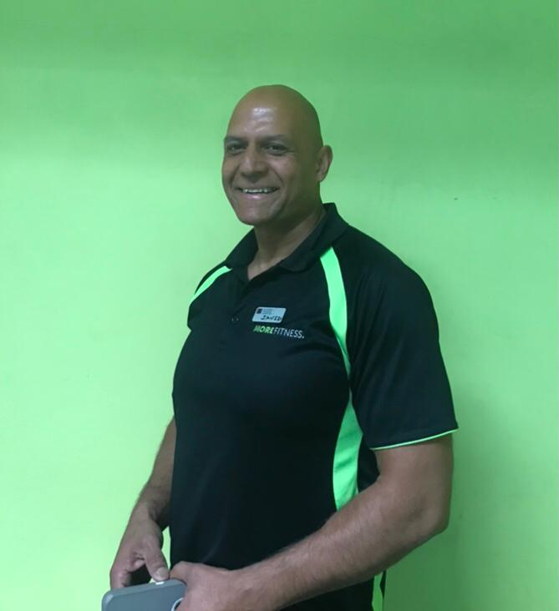

**My Qualifications**

**Personal Trainer** Level 3

**My specialties**

* General fitness and starting with the basics
* Resistance Training (weights)
* Strength Improvement & Conditioning
* HIIT & Endurance
* Weight Management & Weight Loss
* Lean Muscle Building
* Functional Fitness
* Core stability and so much MORE!

**About me**

**Hello, I’m Javid and I’m a certified Personal Trainer!**

**Here at Ladywood, we are more than just personal trainers, we create a fitness experience that turns into a healthier lifestyle.**

I would be thrilled to help you here at Ladywood Leisure Centre. So, lets change your life for the better, together with the hard work you put in.

I can support you with nutritional advise, to help you achieve your goals!

**Nutritional Advisor**

**GP Referral**

Diploma

**Gym Instructor**

Level 2



I’m regulated by:

The Chartered Institute for the Management of Sport and Physical Activity (CIMSPA) Member number 35366

PERSONAL TRAINER PROFILE

Javid

Rahman

**How do you book me?**

Email: javid_rahman@icloud.com

or ask at reception for more details.