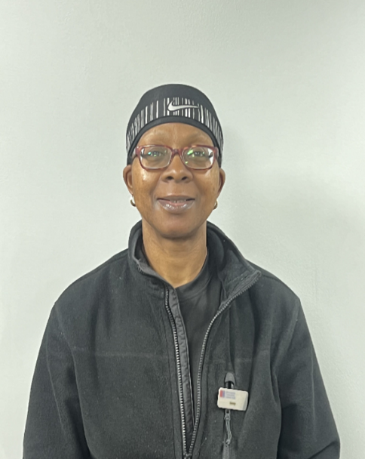

**Gym Instructor**

Level 2

**My specialties**

* General fitness and starting with the basics
* Exercise on Prescription
* FITIN30 Group Classes
* Weight Training
* Body Composition
* Core stability and so much MORE!



I’m regulated by:

The Chartered Institute for the Management of Sport and Physical Activity (CIMSPA) Member number 35366

**My Qualifications**

**Personal Trainer** Level 3

**About me**

Hi, my name is Jenny.

I have been working at Fox Hollies for over 20 years in the Fitness Department.

Working in the gym has been a lifelong passion of mine, so when I got the opportunity, I took the bull by the horns, hence 20 years later I’m still in the business.

I have a wealth of knowledge and experience so believe me when I say I know what I’m talking about when it comes to the gym, whether your young or old, you will achieve your fitness goal.

**I can support achieving the following goals:**

* Weight loss/tone up or get fitter for a special event.
* Improve your stability, strength, speed, power, endurance, fitness, and confidence.

PERSONAL TRAINER PROFILE

Jenny

Robinson

**How do you book me?**

Email: Jenny.robinson@serco.com

Or Ask at reception for more details

**How do you book me?**

Email: rebecca.evans1@serco.com

or ask at reception for more details. (Only available at Fox hollies Tuesday’s & Friday’s)