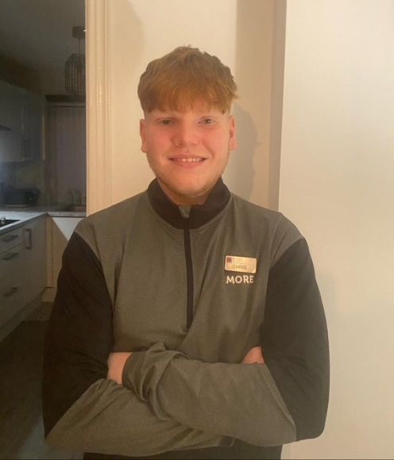

**My specialties**

* General fitness and starting with gym basics
* Resistance Training (weights)
* Strength Improvement & Conditioning
* HIIT, Endurance and circuit training
* Lean Muscle Building
* Functional Fitness
* Core stability and so much MORE!

**About me**

Hello, my name is Chris and I’m a qualified personal trainer, with an ambition to support and help my clients improve their health and wellbeing through fitness. I have experience with training different type of sports athletes and gym athletes.

I’m also doing a level 4 and level 5 Sports coaching and performance science degree from Newman University; I’m only in my first year but hopefully by the end of my degree I can support you with different injuries and help you with injury prevention and give you different advice.

**I can support achieving the following goals:**

* Weight loss and fitness confidence
* Improving your stability, speed, power, and endurance.

I will also create you a personalised and exciting training plan, to keep you motivated and on track with your goals.

**Gym floor classes**

Circuits

FITIN30

**Gym Instructor**

Level 2



I’m regulated by:

The Chartered Institute for the Management of Sport and Physical Activity (CIMSPA) Member number 35366

**My Qualifications**

**Personal Trainer** Level 3

PERSONAL TRAINER PROFILE

Christopher

Burbidge

**How do you book me?**

Email: [Christopher.burbidge16@gmail.com](mailto:Christopher.burbidge16@gmail.com)

or ask at reception for more details.