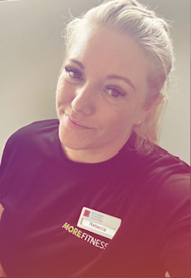

**Group Exercise Instructor**

Body Combat

Body Pump

Indoor Cycling

Circuits

**Gym Instructor**

Level 2

**My specialties**

* General fitness and starting with the basics
* Resistance Training (weights)
* Strength Improvement & Conditioning
* HIIT & Endurance
* Weight Management & Weight Loss
* Lean Muscle Building
* Functional Fitness
* Core stability and so much MORE!



I’m regulated by:

The Chartered Institute for the Management of Sport and Physical Activity (CIMSPA) Member number 35366

**Nutritional Advisor**

**My Qualifications**

**Personal Trainer** Level 3

**About me**

**Hello, I’m Rebecca and I’m a certified Personal Trainer with a passion to help my clients improve their lives through fitness and lifestyle changes.**

**I’m currently based at our Ladywood Centre but will be opening a few hours every Tuesday & Friday here at Fox Hollies to assist you on your fitness journey.**

**I can support achieving the following goals:**

* Weight loss/tone up or get fitter for a special event.
* Improve your stability, strength, speed, power, endurance, fitness, and confidence.

I will create you a personalised, unique, and exciting training plan, to keep you motivated and on track with your goals.

I’ll also provide you with dietary advice with simple, but effective, lifestyle changes to ensure you can become the best version of you!

PERSONAL TRAINER PROFILE

Rebecca

Evans

**How do you book me?**

Email: rebecca.evans1@serco.com

or ask at reception for more details. (Only available at Fox hollies Tuesday’s & Friday’s)