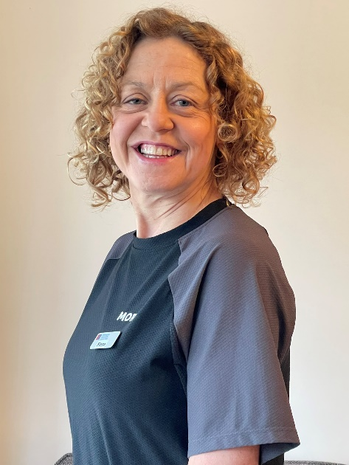

**My specialties**

* Boosting gym confidence
* Establishing lifelong, healthy eating habits to end yo-yo dieting once and for all.
* Weight loss
* Building a lean, strong body that will serve you well.
* Swimming for beginners, improvers (and the terrified!)

**About me**

I was a chubby, clumsy child… useless at sport and always last to be picked for school PE teams.

Fifty years on, I’m at my fittest, leanest and strongest.

So, what happened?

Roped into a 5k fun run in my 30s – I found I could keep going while everyone else stopped and walked (I truly believe there’s a champion inside us all – just waiting to be discovered). I’ll never forget that feeling of pure elation, triumph (and shock!) at the finish line. Finally, I could do something!

I progressed to 10ks, half marathons, marathons (seven in all), triathlons - including sprint, Olympic half and full Ironman distance - and two Tough Guy events. Exercising has done such wonders for my health – both physical and mental – that I’ve recently qualified as a gym instructor, weight management consultant (I run the weekly Momenta sessions here at Wyndley) and personal trainer.

As a busy, post-menopausal, mum of two, juggling several jobs I understand how hard it is to find time to move while keeping all those plates spinning.

But I’m on a mission, now, to help others (particularly fellow women ‘of a certain age’), discover the joys of being fitter, stronger and healthier.

Ready? Let’s do this!

PS I still can’t hit, catch, kick or throw a ball for toffee…

**Gym Instructor**

Level 2

**Group Exercise**

**Instructor**

Circuits

FITIN30

**Weight Management**

**Consultant**

Momenta Course

**Swimming**

**Teacher**

ASA Level 1 and 2

PERSONAL TRAINER & WEIGHT LOSS MANAGEMENT

Fiona

Duffy

**How do you book me?**

Call: **07821594635**

Email: **info@ultimatepersonalwellbeing.co.uk**

or ask at reception for my details.



I’m regulated by:

The Chartered Institute for the Management of Sport and Physical Activity (CIMSPA) Member number 35366

**My Qualifications**

**Personal Trainer** Level 3